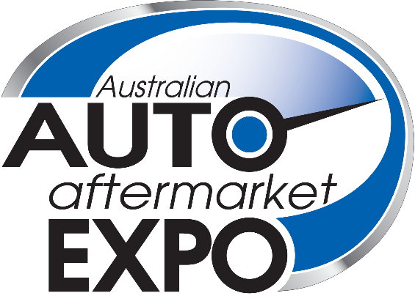

7 April – 9 April 2022
MELBOURNE CONVENTION & EXHIBITION CENTRE

The Australian Auto Aftermarket Expo is the nation’s most comprehensive exhibition of vehicle repair and servicing equipment, replacement parts, tools and accessories. Returning to Melbourne in 2022, industry experts will update businesses on the latest technologies available and the new trends in workshop management.
More than 250 top Australian and international brands will be on display at the Expo. Exhibitor equipment and product demonstrations will be a highlight, with some providing technical presentations and others running competitions.
The Australian Auto Aftermarket Expo will be co-located with the Collision Repair Expo. Entry is free and visitors will be able to check out a combined total of about 250 exhibits over nearly five acres of display space.

Register to visit now at www.aftermarketexpo.com.au

